**Software Requirement Specification (SRS)**

Of

**Student Clearance module**

For Implementation of

**Campus Management Software**

at

**World Skill Center (WSC)**

**Sustainable Outreach And Universal**

**Leadership (SOUL) Limited**

Table of Content

A. Abstract 2

B. Introduction 3

C. Definition, Acronyms and Abbreviations 3

D. Overview of the Document 3

E. Scope of Education Module 4

F. WSC Student Clearance Process Flow 4

G. Process Flow Description 5

H. List of Screens and Their Descriptions 5

I. Student Clearance 6

1. Clearance Master 6

2. Student Clearance Application 7

# Abstract

Software Requirements Gathering is one of the first phases of system development. This phase results in the Software Requirements Specification (SRS) document, which must contain a complete, concise, high-quality description of the system being considered.

# Introduction

The World Skill Center (WSC) is a premier advanced skill training institute established by the Government of Odisha, Skill Development and Technical Education Department, through the Odisha Skill Development Authority (OSDA). The WSC will impart advanced skill training in eight trades from engineering and service sectors. WSC caters primarily to induct the best talent from ITIs and Polytechnics and train them to become globally employable in emerging areas such as "Industry 4.0". WSC is housed in a state-of-the-art, 18-storey, air-conditioned building with nearly half a million square feet of space in the heart of capital city of Bhubaneswar.

With the Implementation of campus management software for WSC the goal is to streamline the operations and functions of the campus by integrating various processes, such as admissions, course registration, academic progress tracking, and financial management, HRMS, Procurement and Inventory management, etc into a unified system. The implementation also aims at providing a user-friendly interface for all stakeholders, making it easier for them to access the necessary information and complete their tasks with ease. The modules to be covered during the implementation of the software includes:

|  |  |
| --- | --- |
| Students Management Modules | Infrastructure Management |
| Academic System | Finance and Accounting System |
| Procurement & Inventory Management | Training and Placement |
| Human Resources Management System | Application Integration |

# Definition, Acronyms and Abbreviations

The following table explains the terms and abbreviations used in the document:

|  |  |
| --- | --- |
| **Abbreviation** | **Description** |
| SRS | Software Requirements Specification |
| SLCM | Student Life Cycle Management |
| R | Rename - When a field is Renamed |
| N | New - When a New field is Added |
| D | Delete - When an Existing field is Deleted |
| NA | Not Applicable |

# Overview of the Document

This requirement document provides a detailed overview of the functional requirements of a project. It serves as a communication tool between stakeholders, including developers, project managers, and end-users. The purpose of this requirement document is to define and document the project's objectives, scope, and expectations, and to ensure that all stakeholders have a clear understanding of what the project entails.

This document covers all the functional requirements of the **Education Student Clearance module** of ERP Product. This module helps in organizing the entire student Separation set-up, such as Student Database, Student Clearance Application Form, etc.

# Scope of Education Module

* Courses and Subjects, Timetable preparation and management  ▪
* Class occurrence monitoring
* Class Attendance of students (Face recognition or any other automated mode).    ▪
* Results Analysis after declaration of results by WSC ▪
* Students Feedback mechanism on quality of teaching learning ▪ Internship, Training, Apprentice ▪
* Re-Admission Process after discontinuing in studies ▪
* Students Back paper tracking etc.
* Students Profile.  :Personal Information, Contact Details, Academic Details ▪
* Issue of Identity Card.  ▪
* Biometric Attendance (Face recognition) ▪
* Hostel Management (Hostel seat allotment, attendance, fees etc) ▪
* Scholarships.  ▪
* Students Profile: Personal Information, Contact Details, Academic Details.
* Re-Admission Process after discontinuing in studies
* Issue of Identity Card
* Faculty Workload / Lesson Plan
* Rewards and achievements. 
* Students’ Evaluation/remarks of Faculty.  ▪
* Students Exams records of all 6 semesters ▪
* Parent Enquiry/Alert/Messaging Management.  ▪
* Messaging System
* Students Grievance System etc.

Following functionalities are covered in this SRS document:

* **Student Clearance** ▪

# WSC Student Clearance Process Flow

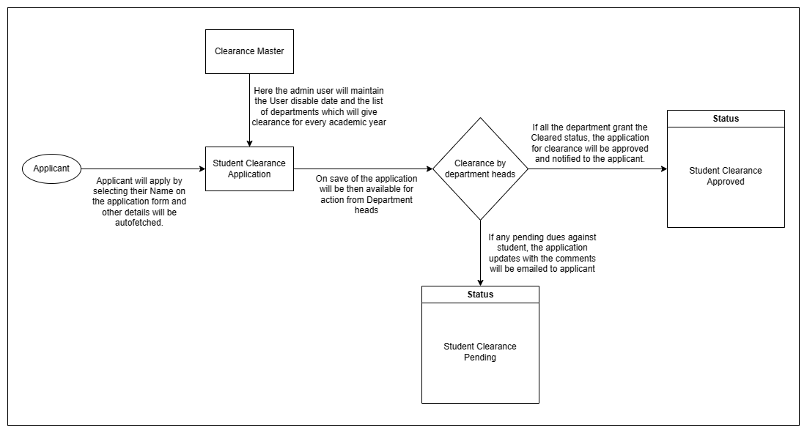

# Process Flow Description

The above flowchart explains the flow of the student clearance process from the applicant applying for the clearance till they receive the approval. Apart from the applicant, department heads will also have access to this screen once the applicant saves the form. The department heads can also raise comments if there is any outstanding due which will be notified to the applicant via email.

# List of Screens and Their Descriptions

|  |  |  |
| --- | --- | --- |
| **Sl no** | **Screen Name** | **Description** |
|  | Clearance Master | In this screen the user can maintain the academic year, User disable date, and the list of departments from whom the clearance is required for the student belonging to the aforementioned academic year. |
|  | Student Clearance Application | The Student clearance Application screen will allow users to apply for clearance once the enrolled course is completed successfully. The student user will select their name and just save. After which, an email will be sent to all the departments mentioned in the application for clearance approval. If any dues is pending against the student in any of the departments, the user can leave a comment which will again trigger a mail notifying the student about the pending dues. |

# **Student Clearance**

# **Clearance Master**

**General Description**

This is a master screen for Student Clearance Application, in this screen the user can maintain the academic year, User disable date, and the list of departments from whom the clearance is required for the student belonging to the aforementioned academic year.

The following table describes overall information about this screen:

|  |  |
| --- | --- |
| **Description** | 1. Admin user will select and add Academic Year. 2. Admin user will select and add User Disable Date. 3. Admin user will click on add row and enter department names from where clearance needs to be obtained. 4. Admin user will click the save button and the record will be saved |
| **Navigation** | Home > Admission> Admission> Clearance Master |
| **Pre-requisites** | The system should have records in the following screen   1. Academic Year 2. Department |

**Screenshot**

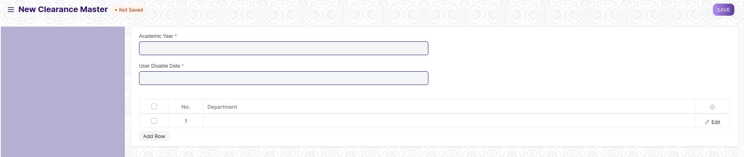

Figure 1: Clearance Master Screen

**Field list**

The following table describes the UI fields present on this screens:

|  |  |  |  |  |  |  |
| --- | --- | --- | --- | --- | --- | --- |
| **ID** | **Field Name** | **Field Type** | **Action / Validation** | Mandatory | **Remarks** | **R/N/D** |
| 1 | Academic Year | Link | Academic Year | Y |  |  |
| 2 | User Disable Date | Date picker |  | Y |  |  |
| 3 | **Clearance Departments** | Table |  | Y | Fields described in the table below |  |

|  |  |  |  |  |  |  |
| --- | --- | --- | --- | --- | --- | --- |
| **Clearance Departments** | | | | | | |
| **ID** | **Field Name** | **Field Type** | **Action / Validation** | Mandatory | **Remarks** | **R/N/D** |
| 1 | Department | Link | Fetched from master screen Department |  |  |  |

**Users: Roles and Permissions**

The following table describes the users and their roles and permissions for the screens:

|  |  |  |  |  |  |  |  |  |  |
| --- | --- | --- | --- | --- | --- | --- | --- | --- | --- |
| ID | Role | Select | Read | Write | Create | Delete | Submit | Cancel | Amend |
| 1 | Admission Management Group | Yes | Yes | Yes | Yes | Yes | Yes | Yes | Yes |

# **Student Clearance Application**

**General Description**

The Student clearance Application screen will allow users to apply for clearance once the enrolled course is completed successfully. The student user will select their name and just save. After which, an email will be sent to all the departments mentioned in the application for clearance approval. If any dues is pending against the student in any of the departments, the user can leave a comment which will again trigger a mail notifying the student about the pending dues.

Once all the Department administrator user check marks the cleared check box in the screen, the status of the application will turn to “Clearance Approved” from “Clearance Pending” which will trigger one final email notifying the student about the approval of their Clearance Application.

The following table describes overall information about this screen:

|  |  |
| --- | --- |
| **Description** | 1. Student user will select and add Student ID and other related details like student name and current academic detail will be auto fetched. 2. Based on the Academic year the User Disable date will also be fetched from the Clearance master.   3. Along with User Disable date the table will be auto populated with the department names from where the clearance needs to be obtained.  4.Student user will click the save button and the records will be saved.  5. The department administrator user will select the check mark button if the student can be cleared from their department and save.  6. Once all the check boxes are selected, the status of the application will turn to “Clearance Approved” otherwise it will remain to be “Clearance Pending”.  7. Finally, user will then submit for successful submission of records. |
| **Navigation** | Home > Admission> Admission> Student Clearance Application |
| **Pre-requisites** | The system should have records in the following screen   1. Clearance Master. 2. Student |

**Screenshot**

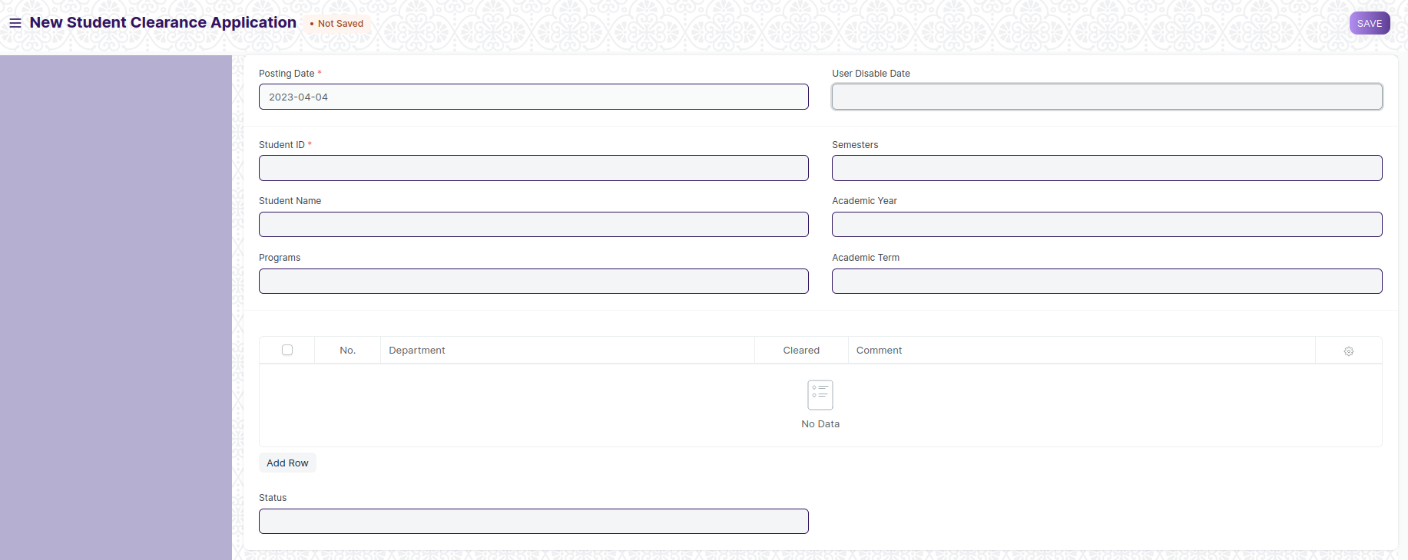

Figure 2: Student Clearance Application Screen

**Field list**

The following table describes the UI fields present in this screens:

|  |  |  |  |  |  |  |
| --- | --- | --- | --- | --- | --- | --- |
| **ID** | **Field Name** | **Field Type** | **Validation/Action** | **Mandatory** | **Remarks** | **R/N/D** |
| 1 | Posting Date | Date | Today’s date |  |  |  |
| 2 | User Disable Date | Date | Auto fetched from Clearance Master based on Academic year |  |  |  |
| 3 | Student ID | Link | Fetched From Master Screen Student | Y |  |  |
| 4 | Student Name | Text | Auto Fetched From Master Screen Student |  |  |  |
| 5 | Programs | Text | Auto Fetched From Master Screen Student |  |  |  |
| 6 | Semesters | Text | Auto Fetched From Master Screen Student |  |  |  |
| 7 | Academic Year | Text | Auto Fetched From Master Screen Student |  |  |  |
| 8 | Academic Term | Text | Auto Fetched From Master Screen Student |  |  |  |
| 9 | Departments Clearance Status | Table |  | Y | Fields described in the table below |  |
| 10 | Status | Text | Auto updated to Clearance Approved/Clearance Pending based on the “Departments Clearance Status” table. |  |  |  |

|  |  |  |  |  |  |  |
| --- | --- | --- | --- | --- | --- | --- |
| **Departments Clearance Status** | | | | | | |
| **ID** | **Field Name** | **Field Type** | **Validation/Action** | **Mandatory** | **Remarks** | **R/N/D** |
| 1 | Department | Link | Auto Fetched From Clearance Departments child table |  |  |  |
| 2 | Cleared | Check box | User Input |  |  |  |
| 3 | Comment | Text | User Input |  |  |  |

**Users: Roles and Permissions**

The following table describes the users and their roles and permissions for the screens:

|  |  |  |  |  |  |  |  |  |  |
| --- | --- | --- | --- | --- | --- | --- | --- | --- | --- |
| ID | Role | Select | Read | Write | Create | Delete | Submit | Cancel | Amend |
| 1 | Admission Management Group | Yes | Yes | Yes | Yes | Yes | Yes | Yes | Yes |
| 2 | Admin Officer | Yes | Yes | Yes | No | No | Yes | No | Yes |
| 3 | Library Head | Yes | Yes | Yes | No | No | Yes | No | Yes |
| 4 | HOD | Yes | Yes | Yes | No | No | Yes | No | Yes |
| 5 | Student | Yes | Yes | Yes | No | No | Yes | No | Yes |